OUT BOUND DIALER (OBD)
Features of service:
Control Panel: Web Based
Integration: Https URL Base Campaign Management
Reports: Real Time Web-based & API based
Outbound Dialing (OBD)
Outbound Dialing (OBD) is a robust system designed to effectively manage automated bulk outbound dialling without any Capex Cost.
The system had option of
- Instantly Dial-out
Or
- Schedule dial-out to a list of mobile users uploaded by the customer as per his requirement.
It an effective tool which any Enterprise requires for its various activities like subscription reminders, alerting to subscriptions, Product Launch etc. Thereby adding immense value over manual operation of such activities on large numbers Database.
Reports can be generated on the Basis of call status.
Key Features
OBD-Outbound Dialer is an automated dialing system that generates simultaneous voice calls to a list of pre identified phone numbers of a target group.
OBD is a powerful, cost-effective Tele-marketing Communication service to promote various programs, advertisements, offers and value-added services to customers with reduced cost and time.
OBD provides reach to more than thousands of target customers in diversified languages.

How it Works
OBD Types
A) Promotional B) Transactional
- Promotional :- In promotional type, Call send from 080 CLI number and DND data has been filter ( which means call not send to the DND numbers)
- Transactional: - In Transactional type, call send from 080 CLI number and DND data has been not filter in it.

Login with the panel details with the shared login URL:- http://blr.paragalaxy.com

User name: - xyz
Password: - 1234

Dashboard Detail: - Screen shot

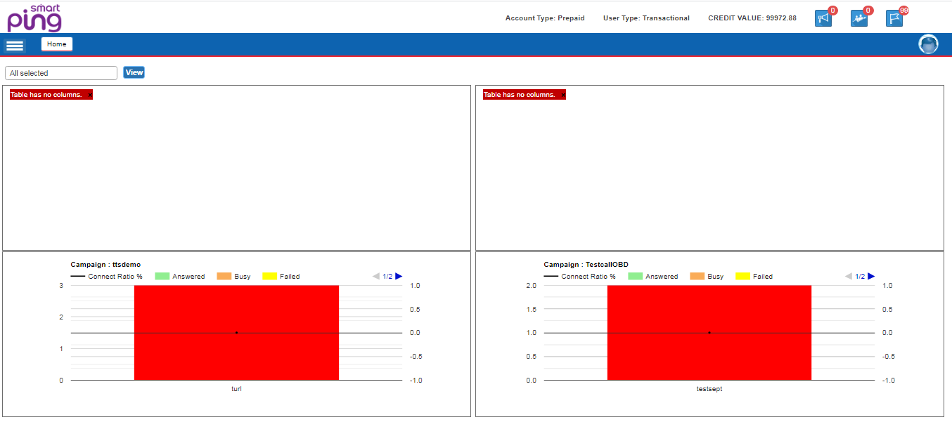

- Account Type: User can view account type Prepaid/Post-paid.
- Credit Value: User can view current Balance.
- User Type: Transactional or Promotional
- Campaign graphically summary: User can view Campaign summary Detail.

Option under OBD Interface
- GUI
GUI: Graphical user interface where user login to system with valid login Credentials and operate OBD interface.

B) Https based Web Service
API: API stands for Application Programming Interface. We have json based api. It works on POST method. User can integrate his application with our API to automate his processes. User name password will be same as used in GUI.

Client Dashboard with it’ A/c Details

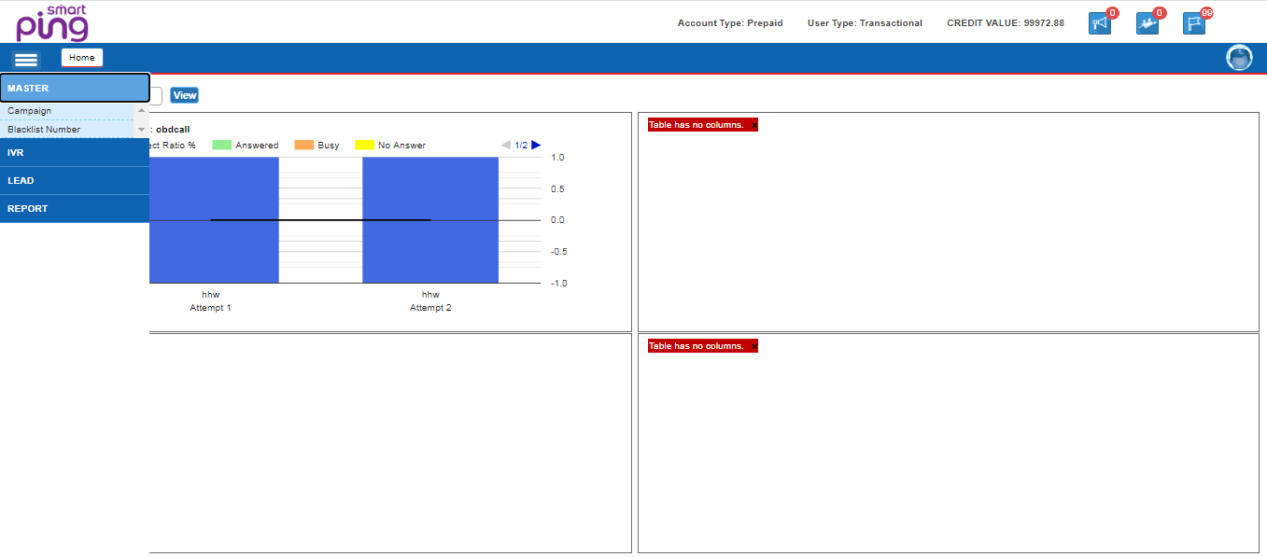

Various OBD Campaign Modules:-

Action required for Campaign Creation: Need to capture and Upload the details as mention below against the Log-in account
- Create Campaign

  - OBD IVR (Simple Voice Campaign)
  - Optional IVR (OBD with DTMF)
  - Info IVR (Customization OBD)

- IVR :-

- Voice file:-
  - Voice file upload (Auto approve)
  - Format of the Voice file .wav

- IVR design:-
  - DTMF and SMS based campaign designed

- Lead Management
  - Lead upload :- User can upload lead or database in lead upload with retry
  - Lead schedule :- current and scheduled

- Report:-
  - Summary Report
  - Detail Report
  - Info Report ( DTMF or customized Report)

Activity completed for campaign execution
NOTE: - All fields are mandatory
In a case, Customer requirement for redirecting the panel with domain, Then we will share the IP based URL to the customer.
---------------------------------------------------------------------------------------------------------------------------------------

